**CHAPTER ONE**

**INTRODUCTION**

## 1.1 BACKGROUND OF THE PROJECT

In the past, every electronic device has its own remote control which is built based on infrared and that means if I have eight devices then I will have as much as eight infrared based remote controls to operate them. These remotes work based on a principle known as line of sight (LOS) and that means one will have to directly face the remote to the device receiver to be able to issue commands. This feature of this remote is inconvenient, now suppose am in my room and wish to switch off home theatre at the sitting room? I will have to walk to where it is and press the required button on the remote.

In recent times people have become very lazy that they find it difficult to even get up and switch ON/OFF their devices which are plugged to power. They would prefer to sit at a place and control their devices with a single remote and that led to the invention of radio frequency remote controls. In developed countries home automation is a norm but developing countries like Nigeria are yet to adapt to this technology. Due to the inconvenience that comes with having lots of remote controls the radio frequency remote control was invented to control almost every device in the house thus eliminating the need of several infrared remotes.

## 1.2 PROBLEM STATEMENT The stress of moving from switch to switch to turn off devices from power is much and can be eliminated.

This project will proffer solution by integrating the ON/OFF switch of electronic devices in one remote so that the user can switch a device from any part of the house wirelessly provided he is not more than 100m from the receiver.

## 1.3 AIM AND OBJECTIVES

The aim of this project is to design and implement a radio frequency remote control which can switch ON/OFF 16 devices from a distance of 100m or less and then receive an ACK for a sent command.

For this aim to be achieved the following objectives are adopted:

* 1. Design of a 5V DC power supply unit required to power the circuit components on the transmitter and receiver side.
  2. Design of a 12V DC power supply unit required to power the transmitter module
  3. Design a keypad control circuit for the transmitter
  4. Design a display unit using Liquid Crystal Display (LCD 16 * 2) on the transmitter side.
  5. Design a switching circuit on the receiver side.
  6. Interface the designed circuits to a PIC16F877A microcontroller which serves as the central processing unit of the system by scanning for when a key is pressed and triggering transmission.
  7. Develop a software program in embedded C language that will control the processes of the microcontroller in transmitter and receiver side.
  8. Build a prototype to validate the functionality of the project.

## 1.4 SCOPE OF THE PROJECT

This project is limited to the development of a radio frequency remote control system which sends out data to the receiver to execute a command. When a button is pressed on the keypad the transmission process is initialized and selected data is encoded and sent to the receiver which decodes the data and takes action based on table of actions pre coded on the microcontroller. The transmitter side has an LCD where it displays what is going on in the transmitter. It informs the user on when to press a key, when the circuit is transmitting and when an acknowledgement is received. At the receiving side the devices are controlled by a logic determined by the microcontroller and switched through a relay. A single key can act as ON/OFF of a particular device.

This is achieved through a microcontroller (PIC16F877A) controlled by software program written in C language which serves as the central processing unit of the entire system.

## 1.5 SIGNIFICANCE OF THE STUDY

This project presents a system which provides solution to having so much remote control for each device and reduces stress of manually turning devices ON/OFF.

More so, by displaying the processes on an LCD the user can easily interact with the system and become familiar with the functionalities of the system.

# CHAPTER 2

**LITERATURE REVIEW**

An embedded system is a computer built to solve only a few very specific problems and is not easily changed. [1] An embedded system usually does not look like computer, often there is no keyboard or monitor but like a computer it has a processor and a software input and output.

A good way of managing electronic device power is by having the controls in a single remote on your hand. It reduces stress and helps conserve energy by ensuring that all the devices go off on power off and remain off until turned on by the remote.

## 2.1 OVERVIEW OF THIS PROJECT

### 2.1.1 RADIO FREQUENCY

Radio frequency (RF) is any of the electromagnetic wave that lie in the range extending from around 3KHz to 300GHz, which include those frequencies used for communications or radar signals. [2]

### 2.1.2 RADIO FREQUENCY MODULE

A Radio Frequency module is a small electronic device used to transmit and/or receive radio signals between two devices. These modules are widely used in electronic design owing to the complexity and difficulty of designing accurate radio circuitry. It uses Amplitude Shift Keying (ASK) modulation technique for its operation. It usually comes in pair’s i.e. a transmitter must have a corresponding receiver which operates at same frequency. The most common RF module is the TLP433/315 and RLP 433/315 where “TLP” indicates that it’s a transmitter and “RLP” indicates that it’s a receiver module. The number attached to the module indicates its frequency of operation in Mega Hertz. The radio signals radiated by the transmitter are modulated and travel a distance of about 100m at maximum voltage which is 12v in all directions penetrating walls and obstacles. The receiver which operates at 5v picks up these signals through its antenna and demodulates them.

### 2.1.3 REMOTE CONTROL TECHNOLOGY

A remote control system possesses the following features: encoding, synchronization, decoding, execution, error detection.

#### Encoding

It is the translation of a message that is easily understood. In this process, the sender uses verbal and non verbal language to send messages which he/she believes the receiver can understand. The symbols can be words and numbers, images, actions etc and it is important how these messages are encoded. [3]

In data communications the messages encoded are in the form of binary.

#### Decoding

The decoding of a message is how an audience member is able to understand and interpret the message. It is the process of interpretation and translation of coded information into comprehensible form. Effective communication is accomplished only when the message is received and understood in an intended way. [3]

#### Error detection

This is the detection of errors caused by noise or other impairments during transmission from transmission to receiver.

* **Synchronization**

This is the process of aligning the transmitter and receiver clock in such a way that data does not arrive out of order. This is achieved by accurate timing.

* **Error Correction**

This is the detection and correction of errors in a transmitted signal at the receiver end. These errors can be corrected either by retransmission of the data or Forward Error Correction (FEC) technique e.g. Hamming Code.

## 2.1.4 ENCODERS

These are integrated circuits that are capable of encoding 12 bit information which consists of N address bits and 12-N bits. [4]

## 2.1.5 DECODERS

These are integrated circuits that are capable of decoding 12 bit information which consists of N address bits and 12-N bits. [4]

## 2.1.6 PIC16F877A

This is a 40 pin microcontroller produced by microchip. It has 32 input/output pins 5 Analog to Digital Converters (ADC), 5 ports which are PORT A, PORT B, PORT C, PORT D, PORT E. it can operate with crystals whose values lie within 1-20MHZ and this crystal provides the clock pulses for the processor [5]. The microcontroller can be interfaced with almost any kind of device to achieve a goal. The way a system built with micro controller behaves depends on the control program written to drive it and the devices it is interfaced with.

## 2.1.7 SWITCHING CIRCUIT

This is where the ON/OFF implementation lies. It consists of 16 30A relays which are interfaced with the microcontroller through a transistor for effective switching. This circuit carries the load which is the electronic device to be controlled. A relay is an electromagnetic device which works based on principles of electromagnetic induction. It has a common (C), normally open (NO) and normally closed (NC) contact. When the relay is de-energized the contact is on the normally closed but when energized the contact is switched to normally open. This feature is exploited in automatically switching a device ON/OFF where a higher voltage is connected to the common and output taken from the normally open. Because the relay requires about 70mA current to be energized and the micro controller which is to energize the relay supplies only about 50mA a transistor is then connected to ensure that the relay gets enough current to energize.

## 2.1.8 DISPLAY CIRCUIT

The display circuit which consists of LCD and other discrete components interfaced with the microcontroller enables the user to follow instructions on what to do by displaying them on the screen. A 16 * 2 LCD is used so as to miniaturize the size of the transmitter. It has about 16 pins where 8 of them are data pins, two controls the backlight, three control the contrast, positive voltage supply and negative voltage supply [6]. The remaining three pins control how commands are issued to the LCD. The dimension 16 * 2 simply means that the screen is divided into two each of 16 pixels and can contain about 32 characters in all.

## 2.1.8 KEYPAD CIRCUIT

While the display unit instructs the user on what to do the keypad enables the user to issue commands as specified on the display using. A keypad is usually made up of monostable switches which are connected in an array or matrix form [7]. A continuous scan is run by the controller in other to detect when a key is pressed and which particular key is pressed so as to execute commands.

## 2.2 REVIEW OF RELATED LITERATURES

LIGO GEORGE [8] attempted to control devices by using the encoder and decoder IC (HT12E and HT12D) interfaced with the ASK RF module and a monostable switch to trigger the transmission when pressed. The interesting aspect of his work is the simplicity with which this was achieved. However he could only control 4 devices because of the limitations of the Encoder/Decoder pins. A better way would have been to interface it with microcontroller to expand the number of inputs and outputs on then transmitter and receiver respectively.

TARUN AGARWAL [9] in a project titled “RF Module-Transmitter & Receiver” developed a system with the same Encoder/Decoder IC but interfaced the encoder with a 20 pin Atmel Micro controller (AT89C2051). By incorporating the micro controller he made his work more flexible as he has more control on when a signal should be sent even without pressing a button. Although he achieved flexibility on the transmitter the receiver was still limited to four outputs as a result of the Decoder IC used.

Instructables.com [10] in a project implemented by R5SB named “Wireless Control of Robot using Arduino and RF Modules” developed a remote control for controlling the movement of a robot by rotating its tyres. He used arduino for the implementation thus eliminating the need for encoder and decoder IC’s. The control protocols ranging from encoding, decoding, synchronization, actuation etc was implemented on software using C language and Arduino libraries. The project is near perfect but cost ineffective considering the fact that you have to buy two arduino’s every time you want to embark on such project. These same protocols can be implemented using just any microcontroller thus saving cost.

KEVIN DARRAH [11] attempted to send temperature and humidity data from one room to another in other to be able to view and control room temperature. He achieved this by using RF modules interfaced with arduinos on the transmitter and receiver side. He implemented the Manchester encoding and filtering protocols in software in other to achieve an efficient communication and control system. The project is cost ineffective in the sense that one would need two arduino’s and a laptop or PC each time such a project is to be implemented. The Laptop is used to view the data sent over through the serial monitor of the arduino. A better approach would have been to use a single microcontroller rather than a whole arduino board and a mini liquid crystal display (LCD) say 16 * 2 to view the data sent over.

## 2.3 SUMMARY OF REVIEWS

The reviews were carried out so as to through more light on some of the similar works carried out by other researchers with respect to radio frequency remote control.

However, this project addresses some of the short comings of the related projects mentioned above. For instance, the work in [8] didn’t consider the fact that there could be more devices to control. This has been taken into account in this work by replacing the encoder/decoder IC with PIC16F877A microcontroller. The work in [11] didn’t consider cost so much by using whole Arduino board for a simple project. This has been taken into account in this work by replacing the arduino board with a single microcontroller and an LCD.

Moreover, this work has a special feature in the sense that it is a two way communication where the receiver can send an acknowledgment to the transmitter on reception of a signal indicating the state of the device.

# CHAPTER 3

**PROJECT METHODOLOGY AND SYSTEM ANALYSIS**

## 3.1 METHODOLOGY

Methodology is the systematic, theoretical analysis of the methods applied to a field of study. It comprises of theoretical analysis of the body of methods and principles associated with a branch of knowledge. Typically, it encompasses concepts such as philosophical or theoretical frame works, theoretical model, phases and quantitative or qualitative techniques. [12]

### 3.1.1 OUTLINE OF THE PROCESS

* **Subsystem identification**

The different sub systems are illustrated in the block diagrams below:

CONTROL UNIT

DISPLAY UNIT

KEYPAD CONTROL UNIT

RF TRANSMITTER & RECEIVER MODULE UNIT

POWER SUPPLY UNIT

**FIG 3.1 Block Diagram of a transmitter Remote Control System**

POWER SUPPLY UNIT

RF TRANSMITTER & RECEIVER MODULE UNIT

CONTROL UNIT

SWITCHING CIRCUIT

**FIG 3.2 Block Diagram of a Receiver Remote Control System**

* **Design/Development of subsystems**

The various subsystems are designed and simulated on Computer Aided Design (CAD) software called proteus. This software enable us model a system in other to ascertain its workability. The various circuit diagrams for the sub systems are shown below:

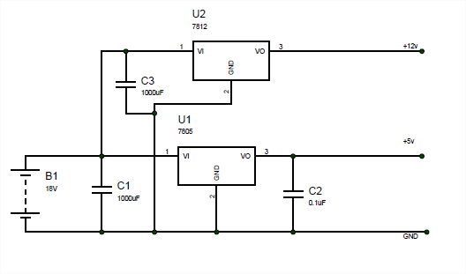

**FIG 3.3a Transmitter Power Supply unit**

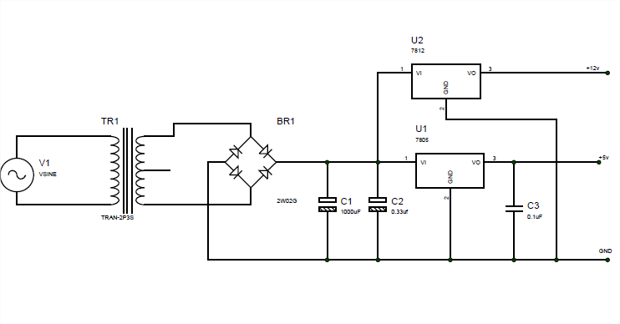

**FIG 3.3b Receiver Power Supply unit**

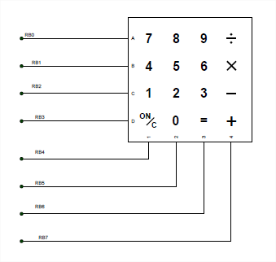

**FIG 3.4 Keypad Control unit**

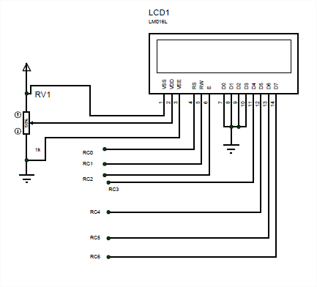

**FIG 3.5 Display unit**

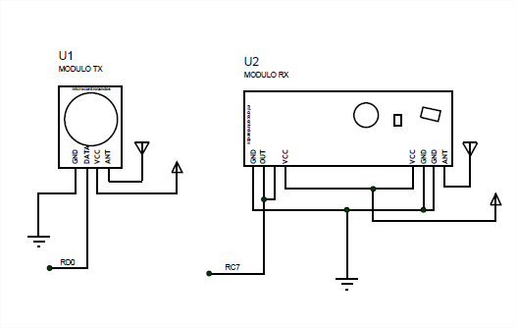

**FIG 3.6 RF Transmitter & Receiver Module Unit**

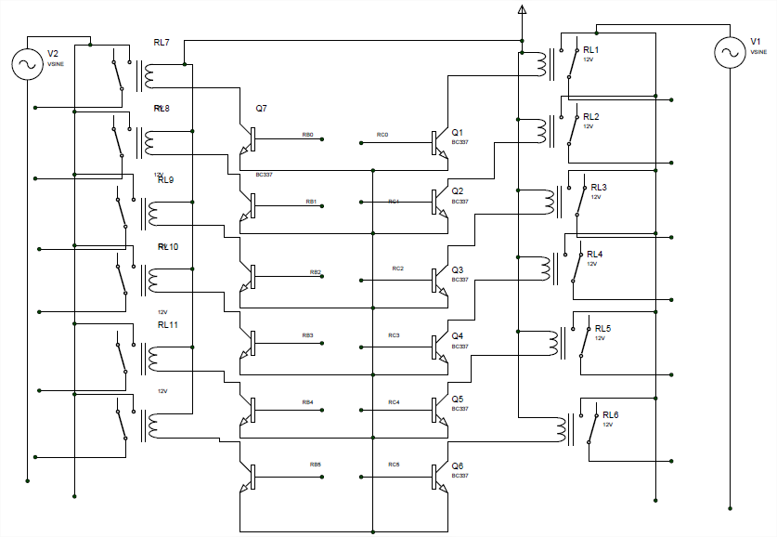

**FIG 3.7 Switching Circuit unit**

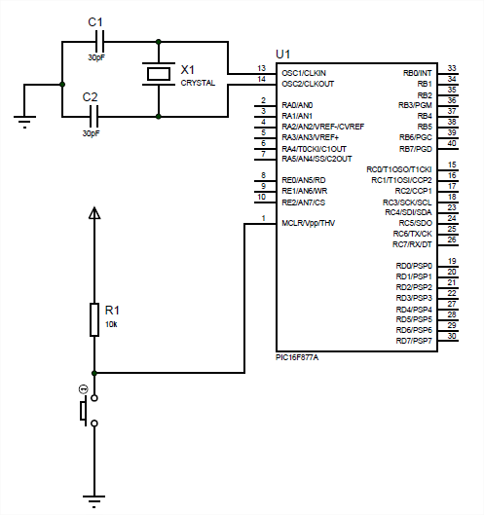

**FIG 3.8 Control unit**

* **Subsystem units integration**

Having simulated the individual subsystem units and upon proper functionality, the various units were integrated to validate the design as shown below:

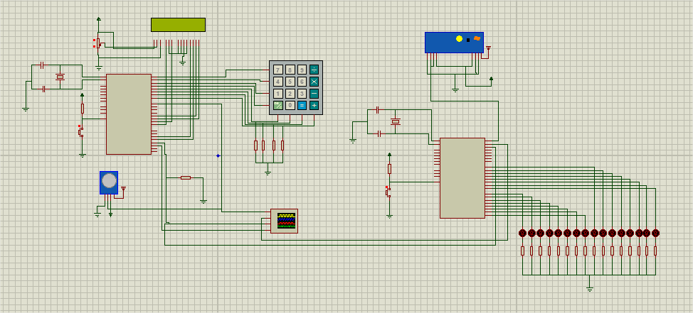

**FIG 3.9 Complete Circuit Diagram of the System**

* **Testing and system analysis**

The complete system was tested, and results obtained showed that it works according to specifications. Hence the design was implemented using hardware.

### 3.1.2 Tools used in the project

The tools used to facilitate the design, simulation and implementation of this project work include

* Proteus 8.0
* MikroC compiler
* PicKit 2 programmer

#### 3.1.2.1 Proteus 8.0

This is a CAD tool developed by Labcenter Electronics. It is software with which one can easily generate schematic captures, develop printed circuit boards (PCB) and simulate microprocessor. It provides a powerful working environment where the user can design different electronic circuits with all the components easily accessible from simple yet effective interface like signal generators, power supply, simple resistor and micro controller. [13]

Its components include:

* **ISIS Schematic Capture**: a tool for entering designs.
* **ARES (Advanced Routing and Editing Software):** is a powerful feature that permits you to route or edit the different components which are used for producing printed circuits.
* **VSM**: Virtual system modelling allows real time design simulation. It is armed with the mixed-mode SPICE simulation
* **System Benefits**: integrated package with common user interface and fully context sensitive help.

#### 3.1.2.2 MikroC Compiler

mikroC is a full-featured ANSI C compiler for PIC devices from Microchip®. It is the best solution for developing code for PIC devices. It features intuitive IDE, powerful compiler with advanced optimizations*,* lots of hardware and software libraries, and additional tools that will help in the development of embedded system projects [14].

#### 3.1.2.3 PICKit 2 Programmer

The PICkit™ 2 Development Programmer/Debugger (PG164120) is a low-cost development tool with an easy to use interface for programming and debugging Microchip’s Flash families of microcontrollers [15].This was used to load the control program into the microcontroller.

## 3.2 SYSTEM ANALYSIS AND DESIGN

### 3.2.1 Structural Analysis

This project work involves the design of a 16 channels radio frequency remote control system with acknowledgement. This system tends to eliminate the use of many remotes to control devices as in the case of infrared remotes and brings all the controls of several devices in one. When a key is pressed data is encoded and sent over to the receiver where it is decoded and action is taken. The process is displayed on an LCD screen to guide the user on the state of the hardware.

In order to achieve these functionalities, the design is made up of four broad blocks:

* The power supply unit
* The control unit
* The input unit
* The output unit

POWER SUPPLY UNIT

CONTROL UNIT

INPUT UNIT

OUTPUT UNIT

**Fig 3.10 Block diagram of the simplified system structure**

#### 3.2.1.1 THE POWER SUPPLY UNIT

Every electronic circuit requires a direct current (DC) power supply to function as virtually all electronic components are operated at DC level. Conventionally, power is supplied in alternating current (AC) form from the public power supply hence the need for rectification arises. A transformer is used to step down the AC source voltage from 230V AC to 12V AC. The 12V AC is passed through a bridge rectifier which converts it to a unidirectional pulsating 12V DC output. The output voltage after rectification is still pulsating because of the presence of ripples. The ripple is filtered out through a filter capacitor.

The microcontroller and most of the peripherals such as the LCD used in this project requires a stable 5V power supply to function, hence LM7805 voltage regulator is used to further convert and regulate the 12V DC to a stable 5V DC .

AC source

Regulator

Transformer

Rectifier

Filter

**Fig 3.11 Block diagram of the regulated power supply**

#### 3.2.1.2 THE CONTROL UNIT

The control unit consists of a microcontroller unit. A microcontroller is a small computer on a single chip in that it contains all the component units of a computer such as the central processing unit (CPU), the memory unit- Random Access Memory (RAM) and Read Only Memory (ROM), input/output unit.

The microcontroller used in this project is PIC16F877A from Microchip Incorporated. The special features of this microcontroller that informed its choice in this project include the following:

* It has current sinking and sourcing capability
* It has reduced instruction set computer (RISC) architecture
* It has built-in analog to digital converter (ADC).
* It has fast response of four (4) clock pulse per instruction cycle.

The detailed features of the PIC16F877Amicrocontroller are as follows:

High-Performance RISC CPU:

* Only 35 single-word instructions to learn.
* All single-cycle instructions except for program branches, which are two-cycle.
* Operating speed: DC – 20 MHz clock DC – 200 ns instruction cycle
* Up to 8K x 14 words of Flash Program Memory, Up to 368 x 8 bytes of Data Memory Up to 256 x 8 bytes of EEPROM Data Memory.

Analog Features:

* 10-bit, up to 8-channel Analog to Digital Converter (A/D)
* Brown-out Reset (BOR)
* Analog Comparator module with:

- Two analog comparators

- Programmable on-chip voltage reference (VREF) module

- Programmable input multiplexing from device inputs and internal voltage reference

- Comparator outputs are externally accessible.

Peripheral Features:

* Timer0: 8-bit timer/counter with 8-bit prescaler
* Timer1: 16-bit timer/counter with prescaler, can be incremented during Sleep via external crystal/clock
* Timer2: 8-bit timer/counter with 8-bit period register, prescaler and postscaler.
* Two Capture, Compare, PWM modules

- Capture is 16-bit, maximum resolution is 12.5ns

- Compare is 16-bit, maximum resolution is 200ns

- PWM maximum resolution is 10-bit

* Synchronous Serial Port (SSP) with SPI (Master mode) and I2C™ (Master/Slave)
* Universal Synchronous Asynchronous Receiver Transmitter (USART/SCI) with 9-bit address detection
* Parallel Slave Port (PSP) – 8 bits wide with external RD, WR and CS controls (40/44-pin only)
* Brown-out detection circuitry for Brown-out Reset (BOR).

Special Microcontroller Features:

* 100,000 erase/write cycle Enhanced Flash program memory typical
* 1,000,000 erase/write cycle Data EEPROM memory typical
* Data EEPROM Retention > 40 years
* Self-reprogrammable under software control
* In-Circuit Serial Programming™ (ICSP™) via two pins
* Single-supply 5V In-Circuit Serial Programming
* Watchdog Timer (WDT) with its own on-chip RC oscillator for reliable operation
* Programmable code protection
* Power saving Sleep mode
* Selectable oscillator options
* In-Circuit Debug (ICD) via two pins
* **PIN DESCRIPTION OF PIC16F877A**

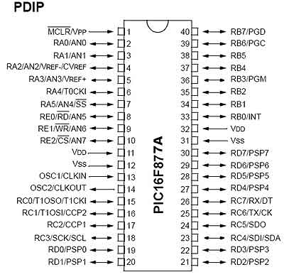

**Fig 3.10 Pin Diagram of PIC16F877A**

The pins of PIC16F877A are described as follows:

**PIN 1: MCLR**

The first pin is the master clear pin of PIC16F877A. It resets the microcontroller and is active low, meaning that it should constantly be given a voltage of 5V and if 0 V are given then the controller is reset. Resetting the controller will bring it back to the first line of the program that has been burned into the microcontroller.

**PIN 2: RA0/AN0**

PORTA consists of 6 pins, from pin 2 to pin 7, all of these are bidirectional input/output pins. Pin 2 is the first pin of this port. This pin can also be used as an analog pin AN0. It is built in analog to digital converter.

**PIN 3: RA1/AN1**

This can be the analog input 1.

**PIN 4: RA2/AN2/Vref-**

It can also act as the analog input2. Or negative analog reference voltage can be given to it.

**PIN 5: RA3/AN3/Vref+**

It can act as the analog input 3. Or can act as the analog positive reference voltage.

**PIN 6: RA0/T0CKI**

To timer0 this pin can act as the clock input pin, the type of output is open drain.

**PIN 7: RA5/SS/AN4**

This can be the analog input 4. There is synchronous serial port in the controller also and this pin can be used as the slave select for that port.

**PIN 8: RE0/RD/AN5**

PORTE starts from pin 8 to pin 10 and this is also a bidirectional input output port. It can be the analog input 5 or for parallel slave port it can act as a ‘read control’ pin which will be active low.

**PIN 9: RE1/WR/AN6**

It can be the analog input 6. And for the parallel slave port it can act as the ‘write control’ which will be active low.

**PIN 10: RE2/CS/A7**

It can be the analog input 7, or for the parallel slave port it can act as the ‘control select’ which will also be active low just like read and write control pins.

**PIN 11 and 32: VDD**

These two pins are the positive supply for the input/output and logic pins. Both of them should be connected to 5V.

**PIN 12 and 31: VSS**

These pins are the ground reference for input/output and logic pins. They should be grounded.

**PIN 13: OSC1/CLKIN**

This is the oscillator input or the external clock input pin.

**PIN 14: OSC2/CLKOUT**

This is the oscillator output pin. A crystal resonator is connected between pin 13 and 14 to provide external clock to the microcontroller.

**PIN 15: RC0/T1OCO/T1CKI**

PORTC consists of 8 pins. It is also a bidirectional input output port. Of them, pin 15 is the first. It can be the clock input of timer 1 or the oscillator output of timer 2.

**PIN 16: RC1/T1OSI/CCP2**

It can be the oscillator input of timer 1 or the capture 2 input/compare 2 output/ PWM 2 output.

**PIN 17: RC2/CCP1**

It can be the capture 1 input/ compare 1 output/ PWM 1 output.

**PIN 18: RC3/SCK/SCL**

It can be the output for SPI or I2C modes and can be the input/output for synchronous serial clock.

**PIN 23: RC4/SDI/SDA**

It can be the SPI data in pin. Or in I2C mode it can be data input/output pin.

**PIN 24: RC5/SDO**

It can be the data out of SPI in the SPI mode.

**PIN 25: RC6/TX/CK**

It can be the synchronous clock or USART Asynchronous transmit pin.

**PIN 26: RC7/RX/DT**

It can be the synchronous data pin or the USART receive pin.

**PIN 19, 20, 21, 22, 27, 28, 29 and 30:**

All of these pins belong to PORTD which is again a bidirectional input and output port. When the microprocessor bus is to be interfaced, it can act as the parallel slave port.

**PIN 33-40: PORT B**

All these pins belong to PORTB. Out of which RB0 can be used as the external interrupt pin and RB6 and RB7 can be used as in-circuit debugger pins [16].

#### 3.2.1.2 THE INPUT UNIT

The input unit comprises the keypad circuit and the receiver unit.

* **The keypad circuit unit**

It consists of a 4 x 4 keypad in matrix form which is interfaced with the micro controller. The 4 x 4 simply means 4 rows 4 columns. The rows are connected to an output port and the columns are connected to an input port.

**Principles of operation**

•The microcontroller scans the keypad continuously to detect and identify the key pressed.

•To detect a pressed key, the microcontroller grounds all rows by providing 0 to the output latch, and then it reads the columns.

–If the data read from columns is D3 -D0 =1111, no key has been pressed and the process continues till key press is detected If one of the column bits has a zero, this means that a key press has occurred.

•For example, if D3 -D0 = 1101, this means that a key in the D1 column has been pressed.

•After detecting a key press, microcontroller will go through the process of identifying the key

–Starting with the top row, the microcontroller grounds it by providing a low to row D0 only

•It reads the columns, if the data read is all 1s, no key in that row is activated and the process is moved to the next row.

•It grounds the next row, reads the columns, and checks for any zero. This process continues until the row is identified.

•After identification of the row in which the key has been pressed, it finds out which column the pressed key belongs to.

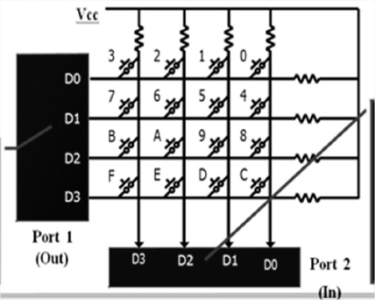

**Fig 3.11 Matrix Keyboard Connection to Microcontroller Ports**

* **The Receiver unit**

This comprises of the receiver module. The input pin of the receiver goes HIGH or LOW based on the radio frequency signal it picks up. The voltage of the input pin ranges from 0v to 5v. When these radio signals are picked up the micro controller detects and processes them according to a given logic see fig 3.6.

**3.2.1.2 THE OUTPUT UNIT**

The output unit comprises the display unit and the switching unit.

* **The Display unit**

In recent years, the LCD (see fig 3.5) is finding widespread use in replacing LED. This is due to the following reasons:

* The declining prices of LCDs.
* The ability to display numbers, character, and graphics.
* Ease of programming for characters and graphics.

The function of each LCD pin is given in the table below:

**Table 4.0: LCD pin description**

|  |  |  |
| --- | --- | --- |
| **Pin** | **Symbol** | **Description** |
| 1  2  3  4  5  6  7  8  9  10  11  12  13  14 | VSS  VCC  VEE  RS  R/W  E  DB0  DB1  DB2  DB3  DB4  DB5  DB6  DB7 | Ground  +5Vpower Supply  Power supply to control contrast  RS = 0, To select command register. RS = 1, To select data register.  Rw= 0, for write , Rw = 1, for read  Enable  Data bus line 0 (LSB)  Data bus line 1  Data bus line 2  Data bus line 3  Data bus line 4  Data bus line 5  Data bus line 6  Data bus line 7 (MSB) |

* **VCC, VSS AND VEE**

The VCC and VSS provide +5V and ground respectively, while VEE is used to control LCD contrast.

* **RS: Register Select**

There are two (2) very important registers inside the LCD. The RS pin is used for their selection as follows. If RS = 0, the instruction command code register is selected, allowing the user to send a command such as clear display, cursor at home, etc. if RS = 1, the data register is selected, allowing the user to send data to be display on the LCD.

* **R/W Read/write**

R/W input allows the user to write information to the LCD or read information from it. R/W = 1, when reading, R/W = 0, when writing.

* **Enable**

The enable is used by the LCD to latch information presented to its data pins. When data is supplied to the data pins, a HIGH-to-LOW pulse must be supplied to this pin in order for the LCD to latch in the data present at the data pins. This pulse must be a minimum of 450ns wide[17].

* **The switching unit**

The major component of this unit is the relay. Relays are electromechanical switch which is used an isolator to isolate two different voltage sources such as DC and AC voltage. A relay is an electrically operated switch. Many relays use an electromagnet to mechanically operate a switch, but other operating principles are also used, such as solid-state relays. Relays are used where it is necessary to control a circuit by a low-power signal (with complete electrical isolation between control and controlled circuits), or where several circuits must be controlled by one signal [20]. The loads controlled in this project are AC powered while the control unit is powered by DC voltage hence the need for an isolator.

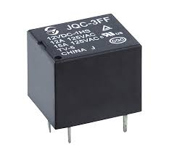

**Fig 3.12 12V DC Relay**

## 3.2.2 OBJECT ORIENTED ANALYSIS OF CONTROL PROGRAM

The control program for the transmitter is meant to scan the keypad to detect when a key is pressed, encode and decode the signal value of the key pressed using Manchester encoding, send a preamble or sync bits to synchronize the transmitter and receiver, transmit data, receive acknowledgement and display commands while the receiver is meant to receiver data, transmit data, encode and decode data, switch devices and send acknowledgments.

### CLASS DIAGRAMS

These are diagrams representing the classes in software which contains the methods, the variables and data type and the class name.

Int values;

assignValueToKeys ();  
scanKeys ();

Keypad

Int signal;  
int counter;

Transmitter

getKeyPressedValue ();

Int signals;  
int dummy;

encode (int signal);   
transmit (int encoded);  
decode (int encoded);  
synchronize (int bits);  
receive ();

SignalProcesses

Int signal;  
int counter;

Switch ();

Receiver

String text;  
int command;  
int row_number;  
int column_number;

clearScreen ();  
writeToScreen ();  
setMode ();  
setRow ();  
setColumn ();

Display

**FIG 3.13 CLASS DIAGRAM OF TRANSMITTER AND RECEIVER**

As shown in fig 3.13 the software is modeled in classes by identifying the nouns, the verbs and values. The nouns form the classes while the verbs or actions form the functions or methods which are sub programs in a class. Since the receiver and transmitter class have most similar functions we create another class called signal processes which holds the common methods of the two classes’ transmitter and receiver. The arrow pointing to the class indicates inheritance. Inheritance in object oriented programming is when an object or class is based on another object or class [18]. Attributes of the super class is passed on to the classes which inherit it and in this case both the transmitter and receiver class will have all the methods in the super class “signalProcesses”.

Int a;  
int b;  
string text;

Move ();  
set ();

Example

The part labeled A is holds the name of the class. The part labeled B holds the variables and data types to be used in the program. The part labeled C houses the methods, functions or sub routines of the program.

### STATE DIAGRAMS

State diagrams are simple diagrams which describe the position or state of a program or function at a particular point in time, the events that causes a change of state and processes within a state.

State=1  
IDLE

ACK RECPTION  
state=5;  
time=0us;  
if time>0 && time<20us  
keep waiting for ACK  
Exit: if time=0us

KEY SELECT  
State=2;   
keypressed=true;  
if key is released  
take key value

Exit: keypressed=false

Key pressed

TRANSMITTING  
state=5;  
time=0us;  
if time >0us &&<8us  
keep transmitting  
Exit: if time=0us

DISPLAY  
state=4;  
time=0us;  
if time >0us &&<8us  
keep displaying transmitting channel  
Exit: time=0us

ENCODING  
State=3;   
time=0us;  
if time >0us &&<8us  
keep encoding  
Exit: if time=8us  
time=0us;

Key released

Time =8us

Time =8us

Time =20us

**FIG 3.14 STATE DIAGRAM OF TRANSMITTER**

State=1;

IDLE

RECEIVING  
no_of_bits=0;  
if no_of_bits<8  
keep receiving;

Exit: no_of_bits=0;